PNNL-xxxx

Surface-to-Air Particle Suspension Formulations: Computed Source Term Release Model, Multimedia Environmental Pollutant Assessment System (MEPAS)®

J. G. Droppo

December 2003

Prepared for
the U.S. Department of Energy
under Contract DE-AC06-76RL01830

Copyright© 1989-2003 Battelle Memorial Institute (?)

PNNL-xxxx

Surface-to-Air Particle Suspension Formulations: Computed Source Term Release Model, Multimedia Environmental Pollutant Assessment System (MEPAS)®

J. G. Droppo

December 2003

Prepared for (who do we list here for this work??)
the U.S. Department of Energy
under Contract DE-AC06-76RL01830

Pacific Northwest National Laboratory
Richland, Washington 99352

Copyright© 1989-2003 Battelle Memorial Institute (??? do we still do this)

Preface

This report is one in a series of reports that document the mathematical models implemented in the Multimedia Environmental Pollutant Assessment System (MEPAS)®. MEPAS which was originally developed by Pacific Northwest National Laboratory for the U.S. Department Energy currently operates within the Framework for Risk Analysis in Multimedia Environmental Systems (FRAMES). The current development work for FRAMES and updates for components such as MEPAS is being funded by (need to acknowledge WES, and other funding sources????)

FRAMES is computer systems for linking source, transport, impact, and related analysis codes in a single platform that includes databases, statistical packages, plotting and viewing capabilities, etc. MEPAS is a set of impact assessment codes and database for physics-based fate and transport models in air, soil, and water media. Outputs of MEPAS are estimates of exposures are health risks.

The updated code for surface-to-air particle suspension formulations is implemented starting in FRAMES 1.3. These revised formulations replace the entire “Section 5.2 Wind Suspension Rate Calculations” in Streile et.al. (1996), Multimedia Environmental Pollutant Assessment System (MEPAS)®: Source-Term Release Formulations, PNNL-11248, Pacific Northwest National Laboratory, Richland, Washington.

Contents

1 Introduction 1-1
2 Surface-to-Air Particle Suspension Models 2-1
3 Revised Formulations for Surface-to-Air Mass Flux Models 3-1
3.1 Emission Rates 3-2
3.2 Vertical Wind Speed Profiles 3-3
3.3 Particle Size Distribution 3-3
3.4 Wind Erosion and Mechanical Suspension 3-5
3.5 Vehicular Suspension 3-12
3.6 Mass Budget for Suspended Materials 3-16
4.0 References 3-17

Summary

Formulations for surface-to-air suspension of particulate material from an area with contaminated surface material are described. The MEPAS Computed Source Term Release Model includes formulations for the release of contamination into air and water. These formulations replace all previously released formulations for the wind suspension rate calculations in the MEPAS Computed Source Term Release Model.

Particle suspension from within a contaminated area from wind and mechanical disturbances is considered. The formulations include particle suspension mechanisms for areas with different levels of wind erosion susceptibility as well as areas with paved and unpaved roadways. The formulations are based mainly on modeling guidance provided by the US Environmental Protection Agency.

The revised formulations apply to the suspension of soil from an area with a contaminated surface soil cover. These formulations include particle suspension models that account for the particle distribution of the suspended materials. The products of these formulations are particle emission rates as a function of particle size ranges as well the total mass loss.
Contents

Introduction

The Multimedia Environmental Pollutant Assessment System (MEPAS) Computed Source Term Release Model, referred to here as the source term model, includes formulations for the simultaneous release of contamination into air and water from a contaminated soil site. The source term model includes formulations for surface-to-air suspension of particulate material from an area with contaminated surface material.

Both the original and revised particle suspension formulations documented in this report are based mainly on regulatory modeling guidance by the US Environmental Protection Agency. The original air-to-suspension formulations for MEPAS (Whelan et.al. 1987) were used with only minor changes in a subsequent model release (Droppo and Buck 1996; Streile et.al 1996). Since those original formulations were released, a number of the particle suspension models, on which the MEPAS formulations are based, have been revised. The revisions have included scientific improvements in the computation algorithms as well as changes to meet new application needs. These revised models have incorporated particle size information – reflecting the recognition of the importance of such information in conducting environmental and health analyzes.

The surface-to-air suspension of particulate material from an area with contaminated surface material represents a loss of contaminated material from the surface and a source of suspended contamination in the atmosphere. The resulting airborne contamination represents inhalation health hazards as well as a downwind secondary source of surface contamination.

Models are required for suspension of particulate matter from surfaces into the air in both source and health impact components of a multimedia modeling systems. Particle suspension results from wind and mechanical disturbances. Potential emissions can occur from areas with a wide variation in surface stabilization as well as from areas with paved and unpaved roadways. The revised formulations incorporate recent particle suspension models including providing emissions as a function of particle size. Equations are given for computing the particle emission rates as a function of particle size as well the total mass loss from an area with a contaminated soil cover.

The next section of this report provides an overview of the various surface-to-air suspension models used in the source and suspension components of MEPAS. Then the following section contains the revised formulations for surface-to-air suspension of particulate material from an area with contaminated surface material. These revised formulations for the surface-to-air particle suspension computations are now implemented in Version 1.3 of FRAMES and replace all previously released formulations for the wind suspension rate calculations in the source term model. (Correct way of saying this in terms of version #s??)

Surface-to-Air Particle Suspension Models

This section provides an overview discussion of the various surface-to-air suspension models required in the source and suspension components of a multimedia modeling system such as MEPAS.

Contaminated surfaces in the environment can result from operations such as waste management (mine tailings, mill tailings, etc.), accidents (spills, leaking storage, etc.) and production/manufacturing activities (liquid discharges to the surface, deposition from airborne plumes, etc.). Such surface contamination can be the result to material stored/released directly on the surface or of migration of buried material to the surface. The potential for suspension of contaminants varies greatly because of the wide variety of surface types and activities expected on the surfaces. If a site has only buried or immobilized wastes, there will be no potential for suspension of particles. If a site has, or in the future may have, exposed surface surfaces with contamination, the potential exists for suspension of contaminated particles to the atmosphere.

The primary source refers the starting point for the environmental analysis and a secondary source refers to the surface contamination that results from deposition of material suspended from the primary source. The contaminated surface for both primary and secondary sources can be a variety of surfaces forms – soil, vegetation, buildings, roadways, etc.

The soil-to-air emission of surface particles may occur from suspension of exposed surface contamination by combinations of mechanical processes. The suspension of particles from the surface may occur as the result of wind action (Bagnold 1941; Sehmel and Lloyd 1976;new refs) or other physical actions on the surface (Sehmel 1976;new refs). Atmospheric turbulence plays a role in determining the extent to which the air movement over the surface can suspend surface particles. Local mechanical activity on the surface, such as animal grazing, vehicular traffic, walking, sweeping, and earth moving can greatly increase the fugitive particulate release rates compared to an undisturbed surface.

Figure 2.1 illustrates the models that are used in the MEPAS formulations to estimate air concentrations resulting from surface suspension processes from both the primary and secondary source areas. Air concentrations are needed at locations both over the source and downwind of the source areas. The “Mass Loading Model” provides a means of estimating exposures directly over primary source contaminated areas and a “Surface Mass Flux Model” provides estimates of the amount of material going into the air from that area. For a secondary source area, a “Suspension Factor Model” is used to estimate the concentrations over the contaminated area. The “Suspension Factor Model” for suspension from secondary sources relies on empirical relationships relating the surface contamination and resultant air concentrations to provide exposure estimates. The mass loading and suspension factor models account for the emission and dispersion processes in a single model using empirical relationships. These mass loading and suspension factor models are used mainly for convenience of estimating the magnitude of exposures in what are often complex situations. These models could be replaced with more detailed physically-based models for specific situations with special modeling requirements.

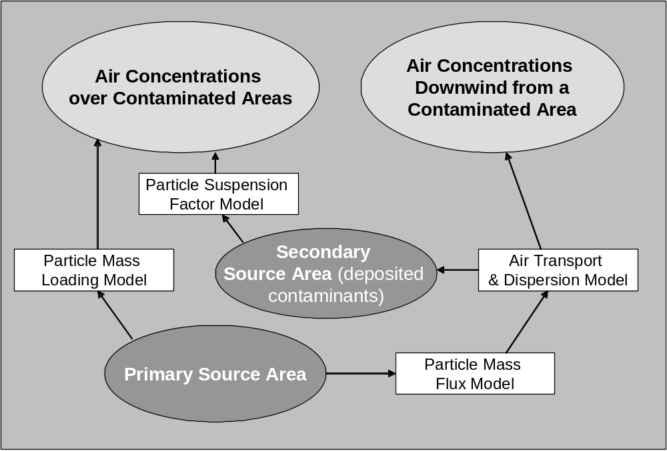
Figure 2.1 Particle Suspension Models for Primary and Secondary Source Areas

Table 2.1 provides characteristics of the various suspension models. Formulations are documented in the following sections for the “Surface Mass Flux Model” for estimating soil suspension rates for a primary source from wind suspension, mechanical disturbances, and vehicles (on roadways). That model connects with an “Air Pathway Model” to provide estimates of air concentration downwind of the source area. Other suspension models are documented in the exposure formulations.

Although the local exposures resulting from suspension are considered, the suspension and transport of the secondary material to downwind locations are not directly considered in these current models. To evaluate a secondary source that may potential represent a significant transport pathway, the secondary source can be considered a new primary source area in a separate scenario.

In summary, depending on the model requirements, different approaches are used to characterize the particle suspension. For input to an air transport model, a detailed mass flux model is used to evaluate the suspension from the primary source. To estimate local air concentrations over both primary and secondary sources, empirical relationships are used.

Model Types | Suspension  Mechanism | Model provides estimate of: | Model Application | Formulation Documentation
Surface Mass Flux | Wind and mechanical actions result in particle suspension | Mass flux from area or roadway to air  (mass/time) | Define rate of release as input to the airborne transport and dispersion computation | This document
Suspension Factor | Disturbances (wind, walking, running, etc.) suspend particles. Uses an empirical “Resuspension Factor.” | Air concentration over contaminated surface (mass/volume) | Local air concentration encountered by an individual located on an area with deposited materials | Exposure formulations
Mass Loading | Assumes a typical mass loading in the air over the site is all from suspension of soil from the site | Air concentration over contaminated surface (mass/volume) | Maximum local air concentration in the air over a contaminated surface | Exposure formulations

Table 2.1 Types of Particle Suspension Models Used in MEPAS

Revised Formulations for Surface-to-Air Mass Flux Models

The suspension of soil particles from contaminated areas is calculated using empirical relationships based on studies of wind erosion and surface disruption. The particulate suspension models use site characteristics to provide a site-specific estimate of particulate emission rates. These formulations do not apply to suspension of contamination from other surfaces.

The particle suspension models used in the MEPAS formulations implemented in FRAMES are listed in Table 3.1. These models include formulations for contaminant suspension by winds, vehicular traffic (paved and unpaved roads), and other physical disturbances of the surface. The formulations for computing suspension rates given below are an adaptation of methodologies promulgated by the US EPA. The original version of these formulations was based on a methodology by Cowherd et al. (1985) for rapid computations of potential annual emission rates from spills of hazardous materials. Since then, EPA has released a number of revised methodologies for their regulatory applications. EPA (1988) provides models for fugitive dust control. EPA (1990) provides a summary of models and their applicability to various applications. In addition, EPA has released pertinent updates to AP-42 (EPA, 1995, 1998, 2002).

The potential for suspension of soil particles depends on the surface cover. Vegetation cover, crusted soil, and moisture content of the soil are important factors considered in the formulations. A wet area (with saturated soil or standing water) is considered to have no potential for wind erosion. The formulations also account for the intermittent times during and after precipitation when the surfaces will be wet and no suspension is assumed to occur.

Computing the suspension of contaminants from a surface into the atmosphere requires both contaminant and site data. In the computed source term model, some of these data are used to define which particle suspension formulations, if any, apply to the site. If a computation is appropriate, the input data are used to compute the suspension rates.

The suspension models promulgated by US EPA categorize the potential of an area for having wind suspension as either “unlimited” or “limited.” Unlimited areas have the potential for the ambient winds alone to suspend particles from the local soil surfaces. Limited areas require some mechanical disturbance of the soil surface for wind erosion to occur.

The models and assumptions that are used estimate the rates of suspension of surface material (i.e. soil) are given below. The source-term release module outputs for suspension from contaminated surface areas are expressed in terms of an airborne soil concentration normalized to a unit area of contaminated surface. These airborne soil concentrations are assumed to contain the same contaminant concentrations as in the surface soil. Thus by knowing the contaminant concentrations in the suspended particulate materials, the contaminant-specific mass or activity suspension rates can be defined.

The formulations given below represent an integration and implementation of several sources of EPA guidance to meet the objectives and constraints of the computed source term model. This process requires a number of linkage and application assumptions (as noted in these formulations). The characterization of the major mechanisms of particulate suspension formulations depends heavily on the approach proposed by Cowherd et. al. (1985). Specific models and components are updated to more recent formulations where possible and appropriate.

Model Type | Mechanism | Model provides estimate of: | Model Application | Model References
Wind Suspension Mass Flux  Model | Unlimited Erosion Potential Area: Wind breaks loose and suspends particles | Mass flux from area to air  (mass/time) | Define rate of release as input to the airborne transport and dispersion computation | Cowherd (1985)
Wind Suspension Mass Flux  Model | Limited Erosion Potential Area: Mechanical disturbances loosen particles that are suspended by the wind | Mass flux from area to air  (mass/time) | Define rate of release as input to the airborne transport and dispersion computation | Cowherd (1985), US EPA, AP-42, rev. dated 1/95
Mechanical Suspension Mass Flux  Model | Paved Road Emissions: Mechanical disturbance by vehicle suspends particles | Mass flux from roadway to air  (mass/time) | Define rate of release air as input to the airborne transport and dispersion computation | US EPA, AP-42, 9/98
Mechanical Suspension Mass Flux  Model | Unpaved Road Emissions: Mechanical disturbance by vehicle suspends particles | Mass flux from roadway to air  (mass/time) | Define rate of release to the air as input to the airborne transport and dispersion computation | US EPA, AP-42, 10/02

Table 3.1 Particle Suspension Models in the Revised MEPAS Computed Source Term Release Formulations

3.1 Emission Rates

The emissions of surface material (i.e. soil) from a site are expressed as the sum of emissions by various particle suspension processes. The output is expressed both as the mass flux in particle size ranges and as the total suspended mass. The latter is expressed as the equivalent depth of soil suspended per year.

The mass flux for each particle size range is the sum of emissions from wind and vehicular suspension over the area:
where E(d_{p}) is total mass flux rate for a particle size range (g yr⁻¹)

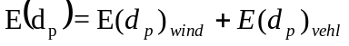 (1)

d_{p} is the particle size range
E(d_{p})_{wind} is the emission rate for wind and mechanical suspension (g yr⁻¹)
E(d_{p})_{vehl} is the emission rate for suspension due to vehicular travel (g yr⁻¹).

The total loss of soil material, expressed as the depth of a surface soil layer, is calculated from the total mass flux as
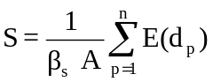 (2)
where S is annual soil depth loss from soil suspension (cm yr⁻¹)
β_{s} is the dry bulk density of the surface soil (g³ cm⁻³)
A is the area over which the soil suspension occurs (cm²)
n is the number of particle size ranges.

The soil depth loss, S, is input to the computed source term model and the total emission rates, E(d_{p}) is input to atmospheric dispersion, transport, and deposition models.

3.2 Vertical Wind Speed Profiles

Wind speed is a critical parameter in estimating the potential particle suspension from a site. Wind speed varies vertically over the surface. To make consistent estimates of suspension rates, the following formulations use a standard reference height for definition of the wind and related parameters. Near-surface vertical wind variation is recognized to vary with the local surface roughness and the stability of that air layer (i.e. the vertical temperature structure. The wind speed profile in the boundary layer for neutral atmospheric conditions can be expressed as a logarithmic wind profile,

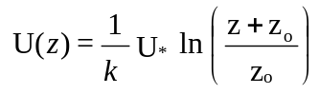 (3)
U(z) is wind speed (m/s)
U* is friction velocity (m/s)
z is the height (m)
z_{o} is the roughness length (m)
k is the von Karmen constant (=0.4) (unitless)

The neutral formulation for wind variation with height alone is sufficient because the high wind conditions being considered in particle suspension computations will be at, or near, neutral atmospheric stability conditions. This relationship is used to adjust average wind speed and fastest mile wind speed to a reference height of 7 meters.

3.3 Particle Size Distribution

A major update in the formulations documented here is the inclusion of particle size information in the emissions resulting from wind erosion (limited and unlimited areas), paved roads, and unpaved roads.

The size distribution of the suspended material is a critical input in terms modeling the fate of the particles and estimating potential health efforts. The size distribution largely determines the environmental deposition rates. In terms of health impacts, the original Cowherd formulation estimated the total mass flux of PM10 (particulate matter with diameters of 10 um or less) which is considered a respirable size range. Subsequently EPA has provided guidance relative to the relative contributions of the mass flux in different size ranges. The PM 2.5 (particulate matter with diameters of 2.5 um or less) represents particles that are more likely to be taken into the lungs. EPA also considered total suspended material (TSP) in their AP-42 revisions.

The emission and movement of particles are considered in multiple size ranges in the following formulations. The EPA guidance provides values for computing a single emission rate for one selected category of particles (i.e. PM 2.5, PM 10, TSP). This EPA guidance is extended to define default mass suspension fractions for different size ranges. These default values are provided in the emission rate formulations given below for situations where such specific site data on suspended size distributions are unavailable.

The particulate size distributions associated with the emissions are represented in these formulations by three model ranges of particulate sizes expressed as index d_{p}. Each range represents the emissions over a specified range of particulate sizes. Table 3.2 shows the properties that are used in the three particulate emission size ranges.

Particle Suspension  Mechanism | Model Particle Emission Ranges
Particle Suspension  Mechanism | 1 |  | 2 |  | 3
Particle Suspension  Mechanism | Mean  Diameter  um | Density  g/cm3 | Mean  Diameter  um | Density  g/cm3 | Mean  Diameter  um | Density  g/cm3
Wind Erosion  (unlimited area) | 0.6 | 1.5 | 6.0 | 1.5 | 15.0 | 1.5
Wind Erosion  (limited area) | 0.6 | 1.5 | 6.0 | 1.5 | 15.0 | 1.5
Unpaved  Road | 0.6 | 1.5 | 6.0 | 1.5 | 15.0 | 1.5
Paved  Road | 0.6 | 1.5 | 6.0 | 1.5 | 15.0 | 1.5

Table 3.2 Default Particle Properties for Model Particulate Emission Ranges

The particulate emission ranges in Table 1.3 represent components of EPA particle size ranges. The “Mean Diameter” is defined to represent different components of the size distribution. The “Density” is value selected as typical of airborne particles. The same default values are used for all the particle suspension mechanisms.

Table 3.3 shows which emission ranges will contribute to the listed particulate size classes. The concentrations for PM-2.5, PM-10, and TSP are computed as the sum of concentrations computed for the particulate emission ranges indicated with a “Yes” is the table. That is, the PM-2.5 is based on Particle Emission Range 1; PM-10 is based on Particle Emission Ranges 1 and 2; etc. The emission fractions are derived from EPA guidance. Particle emissions are reported in ranges so the output can be used in subsequent modules that account for particle size effects.

EPA Particulate  Size Classes | Model Particle Emission Ranges
EPA Particulate  Size Classes | 1 | 2 | 3
PM-2.5 | Yes | No | No
PM-10 | Yes | Yes | No
TSP | Yes | Yes | Yes

Table 3.3 EPA Particulate Size Classes Mapped to Model Ranges

3.4 Wind Erosion and Mechanical Suspension

Particle suspension is considered as the result of the action of 1) wind on a surface to break loose and suspend materials, and 2) mechanical disturbances to break loose materials that can be suspended by the wind. The formulations for these wind erosion and mechanical suspension processes are largely on EPA regulatory modeling guidance as noted below.

A series of EPA documents have addressed wind erosion and mechanical suspension modeling (Cowherd et al, 1985; Cowherd et al, 1988; EPA 1988, 1990, 1995). These documents, all of which use the same general approach, define steps for determining potential particulate emissions from wind erosion. The earlier models provide PM-10 emission rates whereby the later models provide emission rates for different particle size classes (PM-2.5, PM-10, etc.). The condition of the surface, apparent roughness of the site, vegetation cover, presence of a crust on the soil, and presence of nonerodible elements (e.g., large stones) are used to define the potential for suspension. Depending on the results of their procedure, the site is characterized as having 1) unlimited erosion potential, 2) limited erosion potential, or 3) no erosion potential.

The MEPAS source term model addresses suspension of both radionuclides and chemical. The EPA guidance documents are mainly concerned with surface chemical contaminations. The MEPAS implementation (Whelan et al 1987) of the original Cowherd et al (1985) particle suspension formulations was shown to give results comparable to using resuspension factors such as are typically used in studies of the suspension of radionuclides. The comparison considered over a range of surfaces from bare, unstabilized surfaces after a fire to well-stabilized surfaces with a vegetation cover (Whelan et al. 1989).

The experience with radioactive materials shows that there always is some level of suspension of material occurring from natural surface disturbances (Sehmel 1984). However the guidance for the EPA models indicates that if the site has 1) no mechanical disturbances and is completely covered with vegetation, or 2) a thick surface crust, or 3) a wet, saturated soil, it can be assumed that no contaminants are suspended. To allow for the fact that for certain contaminants even very small suspension rates from well-stabilized surfaces may be significant, it is assumed in these formulations that some level of emissions can occur from all surfaces except those saturated with or covered by water.

The EPA models provide criteria for defining an area as have limited or unlimited erosion potential. In the source term model formulations, uncrusted areas are tested to see if unlimited erosion will occur. If not, then the entire area is treated as a candidate for limited erosion. If yes, then the uncrusted area is treated as an unlimited erosion area and the remaining crusted area as a limited erosion area.

The wind/mechanical emission rate for each of the particle size ranges is computed as the sum of the unlimited and limited erosion emissions:
where E(d_{p})_{lim} is the annual average limited emission rate per unit surface area (g yr⁻¹)
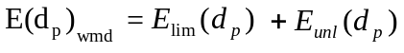 (4)
E(d_{p})_{unl} is the annual average unlimited emission rate per unit surface area (g yr⁻¹).

The emission rates for all defined particle ranges are output. These data allow the users to evaluate, in subsequent air transport modules, the airborne concentrations resulting from the suspended particles over, and nearby the source.

3.4.1 Limited Erosion Calculation

The particle suspension mechanism for an area with limited erosion potential is to have some mechanical disturbance break up some portion of the surface materials and make them available for wind erosion. The particle suspension will thus occur when a wind event occurs that is great enough to suspend these surface materials.

A detailed approach for estimating particle suspension from limited area based on analysis of episodic high wind-speed events has been promulgated by EPA (Cowherd 1985, EPA, 1988; EPA 1995). That approach accounts for the reoccurrence periods of conditions expected to suspend loose surface material. Within the constraints of current implementation of the computed source model, the complete details of that approach could not be entirely implemented. A conservative screening approach derived from the EPA approach is used for estimating the limited erosion potential. That derived approach assumes that suspension events occur each month of the year at a strength equivalent to the maximum monthly event. This derived approach provides an order-of-magnitude estimate of annual potential emission rates. For a separate more detailed site-specific analysis that considers specific events and their occurrence frequencies, the updated EPA (1995) formulations are recommended to compute a “known flux” emission rate for specific limited erosion area.

The potential for wind erosion is quantified in terms of a threshold friction velocity. The greater the value of the threshold friction velocity for a site, the lower will be the potential for particle suspension. The threshold friction velocity for the contaminated area is determined by applying the mode of the aggregate particulate size distribution (which is derived from the soil composition) in an empirical graphical relationship (represented here as a formula) given by Gillette (1980):

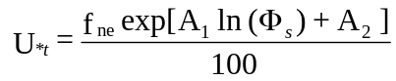 (5)
where U_{*t} is the threshold friction velocity (m s⁻¹)
f_{ne} is the nonerodible elements correction factor (unitless)
Ф _{s} is the mode of the aggregate size distribution (mm)
A₁ is a constant (= 0.4118428)
A₂ is a constant (= 4.167173)

An approximate value for the mode of the aggregate size distribution was estimated in previous formulations using

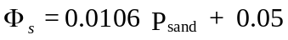 (6)
where P_{sand} is the percent sand (unitless). This relationship is very approximate and should only be used for screening and scoping evaluations.

From the viewpoint of increasing the potential for suspension, this relationship provides relatively realistic estimates for soils with greater than 75% sand content. For other soils, the relationship provides relatively conservative estimates that are more typical of disturbed soils than undisturbed soils.

The correction factor, f_{ne}, in Equation 5.39 allows for the effects of any non-erodible elements in the contaminated area. This correction factor depends on the fraction of surface coverage and is estimated from graphical results given by Cowherd et al. (1985), derived from wind tunnel studies by Marshall (1971). As the silhouette area of nonerodible elements increases, so does the threshold friction velocity. If the threshold friction velocity is less than 0.75 m s⁻¹, the area has unlimited erosion potential; otherwise, the area has only limited erosion potential (Cowherd et al. 1985).

Once the threshold friction velocity has been determined, the critical wind speed at a given height above the surface can be determined by applying Equation (3):

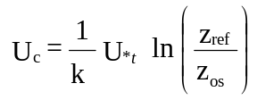 (7)
where U_{c} is the critical wind speed at the reference height above the soil surface (m s⁻¹)
U_{*t} is the threshold friction velocity
z_{ref} is the reference height above the soil surface (m)
z_{os} is a typical surface roughness length for the contaminated area (m).

This relationship requires that the magnitude of reference height is enough greater than that local surface roughness lengths that a representative horizontal wind can be defined at the reference height. The critical wind speed is one of the parameters used below to define the erosion potential. The reference height of 7 m from Cowherd (1985) is consistent with the critical value used above to define limited/unlimited areas based on threshold friction velocity. EPA (1995: Table 13.2.5-2) gives examples threshold friction velocities and threshold wind speeds for a variety of natural surfaces.
The surface roughness length of the site, z_{os}, is related to the size and spacing of the roughness elements in the area.

For a contaminated area having limited wind-erosion potential, the following equation from Cowherd et al. (1985) is used to predict the flux particulate mass density:

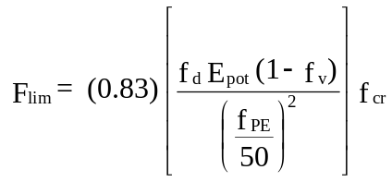 (8)
where F_{lim} is the particulate mass flux density (g/hr/m2)
f_{d} is the area-fraction weighted frequency of mechanical disturbances (mo⁻¹)
E_{pot} is the erosion potential (g m⁻²)
f_{v} is the vegetation coverage on surface (unitless)
f_{PE} is the Thornthwaite's Precipitation-Evaporation (PE) Index (unitless)
f_{cr} is the fraction of soil surface that is crusted (unitless).

The frequency of disturbances per month, f_{d}, is defined as the number of actions that could expose fresh surface material. If the entire area is not disturbed, this frequency should be weighted to reflect the actual area exposed. A disturbance could be vehicular traffic, plowing or turning of the soil, mining, or construction. However, vehicular traffic is accounted for by separate expressions described in the next section. The erosion potential for a dry exposed surface, E_{pot}, depends on the maximum wind speed between disturbances so that

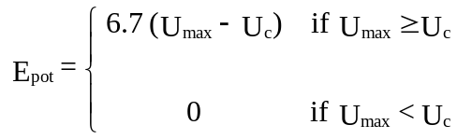 (9)
where U_{max} is maximum wind speed between each disturbance at a reference height above the soil surface (m s⁻¹). To simplify the analysis, a single conservative value is used to characterize the maximum wind speed between the disturbances. The recommendation is that a mean value of wind speeds reported for the climatological monthly Fastest Miles.

The vegetation fraction, f_{v}, varies from 0 for bare ground to 1 for total coverage. The Thornthwaite's PE Index, f_{PE}, is used as a moisture-correction parameter for wind-generated emissions. Cowherd et al. (1985) provides a map with values of f_{PE} for all regions in the contiguous United States.

The above equation for limited emission, E_{lim}, provides a method of rapidly estimating potential emission rates (Cowherd, 1985). However for estimating more realistic site-specific industrial emission rates, each erosion event must be treated separately. The non-linear nature of the erosion potential function makes this event-based analysis necessary (EPA, 1988, EPA 1995).

This mechanism of suspension represents intermittent events. Although the sum of emissions from the events over a year will provide an estimate of the annual emission rate, the use of this value as an average emission rate must be done with some care. Although the nature of formulations (such as a sector average Gaussian model) makes the distribution of wind speeds relatively unimportant in the concentration computation, the question of wind direction is very important. This formulation assumes that the wind suspension events are localized phenomena and the resulting emission rate is appropriate for estimating an annual load of suspended particles that are transported away by the range of ambient winds that occur at the site. That is, this formulation assumes the particles suspended by these wind-driven events over a large number of events are transported in all directions by the local winds with a probability related to frequency of winds in each direction. This assumption assures a wind frequency-based impact on all potential receptors in all directions. However the approach will tend to underestimate the peak concentrations for specific sets of conditions. For the latter, separate event specific computations are recommended.

This formulation applies only a surface where single representative values of surface roughness and frequency of disturbance exist. In general the formulations should not be applied to areas although reasonable estimates of emissions may be estimated by conducting separate runs to evaluate the potential emissions from the different portions of the area.

This particle suspension model for a limited area provides an estimate of the flux of PM-10 particulate material into the air. To estimate fluxes for distinct particle size ranges, this emission rate needs to be converted to equivalent to particle-based range emissions.

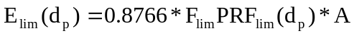 (10)

where PRF_{lim}(d_{p}) is unitless particle range factor, A is the area as defined above, and 0.8766 is a units conversion (from “per hour” to “per year” and “cm²” to “m²”). The particle range factor is defined to be consistent with EPA particle emission guidance for different particle size categories. The factor has a value of 0.4, 0.6, and 1.0 for the 1, 2, and 3 model particle emission ranges (as defined above), respectively.

3.4.2 Unlimited Erosion Calculation

The formulations for the total PM-10 emissions from an unlimited erosion area use the “Gillette Model” discussed in US EPA (1990) and documented in Cowherd et al. (1985). Recent guidance EPA(1995) is used to define a particulate size distribution by assuming that the emissions from a limited and unlimited area will have the same size distributions.

EPA does not currently provide guidance for modeling particle emissions from an unlimited erosion area. Instead the analyst is directed to models developed by other agencies for special applications such as farmland. Although collaborative efforts to develop multi-agency models in this area have been undertaken over the past decade, the results of these efforts do not appear in regulatory guidance. As a result the earlier model (EPA 1990; Cowherd et al 1985) for an unlimited erosion area was deemed to continue to be an appropriate model for estimating particle emissions from an unlimited in the context of applications for the computed source model.

The annual emission rate from erosion from an unlimited erosion area (Cowherd et.al. 1985) is

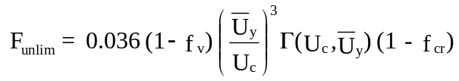 (11)
where F_{unlim} is the average dust emission flux density for PM-10 particles (g/m2/hr)
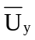 is the mean annual wind speed (m s⁻¹)
A_{s} is the area of the source (m²)
Cu is a units conversion factor from g hr⁻¹ to g yr⁻¹.
Г (U_{c}, ) is a an empirical suspension function defined below.

The vertical flux of particles smaller than 10 μm in diameter is assumed to be proportional to the cube of the horizontal wind speed. This relationship was originally developed from measurements made by O'Brien and Rindlaub (1936) in studies at the mouth of the Columbia River and later measurements made by Bagnold (1941) in the Egyptian desert. Chepil (1951) found this same relationship using results from wind-tunnel experiments.

The integration function, Г (U_{c}, ) , comes from the cubic relationship of the vertical transport of particles and the wind speed. It is defined in graphical format by Cowherd et al. (1985). This relationship can be broken into the following discrete parts based on the values of the non-dimensional scaling parameter, ω:

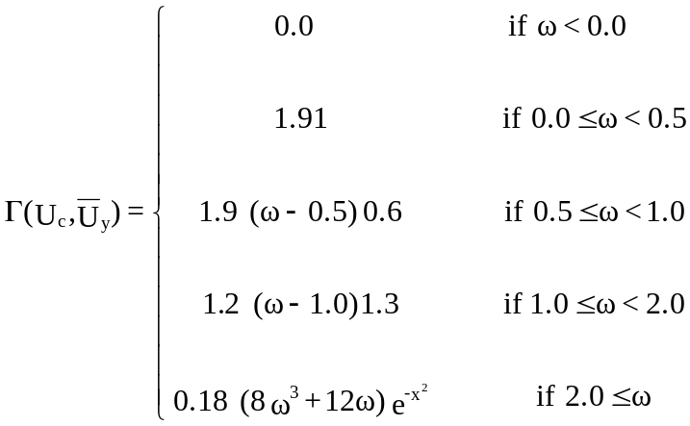 (12)
where ω = 0.886 (U_{c}/) .

This particle suspension model for an unlimited area provides an estimate of the flux of PM-10 particulate material into the air. To estimate fluxes for distinct particle size ranges, this emission rate needs to be converted to equivalent to particle-based range emissions:

(13)

where PRF_{unlim}(d_{p}) is unitless particle range factor, A is the area as defined above, and 0.8766 is a units conversion (from “per hour” to “per year” and “cm²” to “m²”). The particle range factor is defined to be consistent with EPA particle emission guidance for different particle size categories. The factor has a value of 0.4, 0.6, and 1.0 for the 1, 2, and 3 model particle emission ranges (as defined above), respectively.

3.5 Vehicular Suspension

Although both unpaved road surfaces and paved surfaces contribute to the roadway emissions, the unpaved roads have by far the greatest potential for emissions. The original roadway suspension formulation from Cowherd et al. (1985) only included unpaved roads. The 1989 MEPAS implementation of Cowherd added an estimate for paved roads to the approach for air quality modeling. Subsequently the formulations in the EPA’s AP-42 guidance for vehicular particle suspension have undergone a number of revisions. The particle suspension formulations in computed source term model use the most recent formulations in EPA’s AP-42 guidance vehicular suspension.

For emissions resulting from the mechanical disturbances by vehicle traffic on unpaved and paved roadways, the total roadway emissions for particle size ranges are computed as the sum of the unpaved and paved roadway emissions from within the source area.

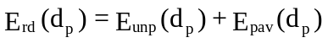 (14)
where E_{unp} is the mass emitted on unpaved roads within the contaminated area (g yr⁻¹)
E_{pav} is the mass emitted on paved roads within the contaminated area (g yr⁻¹)

3.5.1 Unpaved Roads

The unpaved roadway mass flux, F_{unp} is computed using the relationship given in AP-42 (EPA, 1998, page 13.2.2-3) which includes parameterization as a function of particle classes. The equation when expressed in metric units is:

where F_{unp}(c_{p}) is mass flux per unit distance of unpaved road traveled per vehicle for a specified particle size class (g vehicle⁻¹ km⁻¹)
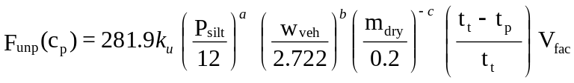 (15)
c_{p} is the particle size class (see Table 1.3)
k_{u} constant for particle size class (see Table 1.3)
a constant for particle size class (see Table 1.3)
b constant for particle size class (see Table 1.3)
c constant for particle size class (see Table 1.3)
P_{silt} is the percent silt plus very fine sand (unitless)
w_{veh} is the mean vehicle weight (Mg)
m_{dry} is the surface material moisture content under dry, uncontrolled condition (%))
t_{t} is the number of days per year (= 365.25) (days)
t_{p} is the number of days with at least 0.254 mm (0.01 in.) of precipitation per year (days)
V_{fac} is a vehicle speed factor (unitless)

The V_{fac} term reduces the predicted emission rates at low wind speeds. For vehicle speeds of less than 24.14 km/hr (15 mph), the term is computed using:

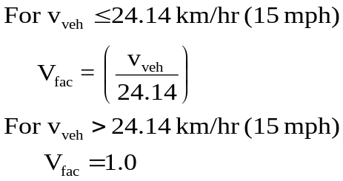 (16)
where v_{veh} is the average vehicle speed (km hr⁻¹⁾.

The unpaved roadway mass flux is computed on an annual basis. The emission rates for the EPA particle size classes are converted to equivalent emission rates for particle size ranges by assuming the rates for the classes are cumulative representations of the rates for the ranges. That is, the value of Funpr(d_{p}) is computed for each of the three particle size ranges as:

For d_{p} = 1: F_{unpr}(d_{p}) = F_{unp} (PM-2.5)
For d_{p} = 2: F_{unpr}(d_{p}) = F_{unp} (PM-10 ) - F_{unp} (PM-2.5) (17)
For d_{p} = 3: F_{unpr}(d_{p}) = F_{unp} (PM-30 ) - F_{unp} (PM-10) - F_{unp} (PM-2.5 )

where F_{unpr}(d_{p}) is the normalized emission rate (mass flux per unit distance of unpaved road traveled per vehicle) within a specified particle size range (g vehicle⁻¹ km⁻¹).

For suspension of particles due to vehicular traffic on unpaved contaminated surfaces, the emission rate is computed from formulations recommended in AP-42 Miscellaneous Sources, (EPA, 1998; Section 13.2.2, version date of 9.98):

where t_{unp} is the number of days of vehicle traffic (assumed equal to 365.25) (days)
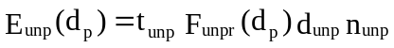 (18)

d_{unp} is the distance of travel over contaminated surface (km)
n_{unp} is the average number of vehicles traveling over the contaminated surface per day (vehicle d⁻¹).

Table 1.3 Particle Class Constants for Computing Unpaved Roadway Emissions (EPA, 1998)
 | EPA Particle Class
Constant | PM-2.5 | PM-10 | PM-30ª
K_{u} (g/VKT)  a  b  c  EPA Quality Rating  When Vehicle Speed is over 24.14 km/hr  (15 mph)  When Vehicle Speed is under 24.14 km/hr  (15 mph) | 107.12  0.8  0.4  0.3  C  D | 732.94  0.8  0.4  0.3  B  C | 2819  0.8  0.4  0.3  B  C
ª Assumed in EPA guidance to be equivalent to total suspended particulate (TSP).

Site-specific information from local sources is normally obtained for each of the parameters. When site-specific data are not available, the default values given in AP-42 US EPA (1998) may be used.

3.5.2 Paved Roads

The pollutant emission caused by traffic on paved roads is computed using the relationships given in AP-42 (EPA, 2002, section 13.2.1). These relationships for paved roads may be expressed in a metric form as:
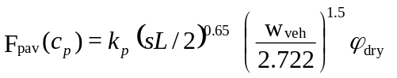 (19)
where k_{p} constant for particle size class (see Table 1.4)
sL is road surface silt loading (g/m²)
w_{veh} is the mean vehicle weight (Mg)
ϕ_{dry} is the surface material moisture content under dry, uncontrolled conditions (%))
F_{dry} is a dry surface duration factor that accounts for the time with dry surfaces (unitless).

Table 1.4 Particle Size Multipliers for Paved Road Emission Computation (EPA, 2002)

EPA Particle  Size Class | Particle Size Multiplier, k_{p}
EPA Particle  Size Class | g/VKT
PM-2.5  PM-10  PM-15  PM-30 | 1.1  4.6  5.5  24.

The paved roadway mass flux is computed on an annual basis. The emission rates for the EPA particle size classes are converted to equivalent emission rates for particle size ranges by assuming the rates for the classes are cumulative representations of the rates for the ranges. That is, the normalized emission rate is computed for each of the three particle size ranges as:

For d_{p} = 1: F_{pavr}(d_{p}) = F_{pav} (PM-2.5)
For d_{p} = 2: F_{pavr}(d_{p}) = F_{pav} (PM-10 ) - F_{pav} (PM-2.5) (20)
For d_{p} = 3: F_{pavr}(d_{p}) = F_{pav} (PM-30 ) - F_{pav} (PM-10) - F_{pav} (PM-2.5 )

where F_{pavr}(d_{p}) is the normalized emission rate (mass flux per unit distance of paved road traveled per vehicle) within a specified particle size range (g vehicle⁻¹ km⁻¹). The PM-15 multiplier in Table 1.4 is not used in the current formulations.

For suspension of particles due to vehicular traffic on paved roads, the emission rate is computed using formulations recommended in AP-42 Miscellaneous Sources, (EPA, 2002; Section 13.2.1, version date of 10/02):
where F_{pav} (dp) is the normalized paved roadway mass flux (g vehicle⁻¹ km⁻¹)
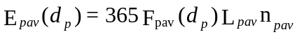 (21)

365 is a unit conversion factor (days yr⁻¹)
L_{pav} is the distance of travel over the contaminated surface (km)
n_{pav} is the average number of vehicles traveling over the contaminated surface per day (vehicle d⁻¹).

Using the frequency of diurnal precipitation at the site, the factor can be estimated using:
where
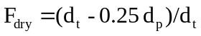 (22)
d_{t} is the number of days in averaging period (e.g., 365 for annual) (days)
d_{p} is the number of days with at least 0.254 mm (0.01 in.) of precipitation in the averaging period (hours)

This relationship for F_{dry} is the most convenient to use because the required data are available in standard local climatological summaries published by NOAA. A factor of 0.25 accounts for the fact that the paved surface may be dry during much of a day when precipitation is reported.

The alternative form for F_{dry} is based on the number of hours with reported precipitation:

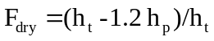 (23)
where
h_{t} is the number of hours in averaging period (e.g., 8760 for annual) (hours)
h_{p} is the number of hours with at least 0.254 mm (0.01 in.) of precipitation in the averaging period (hours)

The second equation for F_{dry} requires an estimate of the number of hours of precipitation during the annual computation time. This parameter may be obtained by analyzing an hourly surface observation dataset available from NOAA taken at an appropriate weather observations site located in the vicinity of the suspension site. This equation includes a factor of 1.2 to account the paved surface staying wet for some time period after each precipitation event ceases.

The first equation will be appropriate for most sites. For the United States, the F_{dry} factor will almost always be greater than 0.9 for areas with less than 50 inches of precipitation per year. For those stations, even a factor of two change in the estimated duration of precipitation will result in a five percent (or less) change in the computed emission rate. As a result, the first equation normally provides more than adequate accuracy for estimation of annual particulate emission rates.

3.6 Mass Budget for Suspended Materials

The total mass flux from the contaminated area is the sum of the mass lost from all the particulate size ranges minus the amount of suspended material that re-deposits on the area. The amount of material deposited will vary with particle size range – with larger particles having much higher rates of deposition on, and nearby, the source area.

The computed source term model assumes that some fraction of the suspended material will deposit in the immediate area and be still available for future suspension, leaching, runoff, etc. The model does not have formulations that allow direct computation of the amount and pattern of these deposited materials. So as a first approximation, it is assumed that all material suspended in the greater that PM-10 size range is assumed to deposit back on the immediate area. The net mass loss from the contaminated area is assumed to be equal to the mass suspended in the PM-10 size ranges. Test runs using the MEPAS air transport model indicates that this assumption is reasonable but conservative in terms of estimating the mass loss from the source area. Through this assumption, the possibility of artificially depleting the potential source term of a material by not accounting for re-deposition in the region is avoided.

The computed source term model performs an overall mass budget on the source material as described in Streile et.al. (1996). The relationship for computing the rate of mass lost from suspension of particles is expressed in terms of the effective depth of soil lost with time (Equation 2). The suspension of particles continues until all the mass contained in the source term is lost.

4.0 References
Bagnold, F. A. 1941. The Physics of Blown Sand and Desert Dunes. Matheson, London.
Chepil, W. S. 1951. "Properties of Soil Which Influence Wind Erosion: I. The Governing Principle of Surface Roughness." Soil Sci. 69:142-162.
Cowherd, C., G. E. Muleski, P. J. Englehart, and D. A. Gillette. 1985. Rapid Assessment of Exposure to Particulate Emissions from Surface Contamination Sites. EPA/600/8-85/002, Prepared for U.S. Environmental Protection Agency, Office of Research and Development, Washington, D.C.
Cowherd, C., G. E. Muleski, and J.S. Kinsey. 1988. Control of Open Fugitive Dust Sources. Office of Air Quality Planning and Standards, U.S. Environmental Protection Agency, Research Triangle Park North Carolina, EPA-450/3-88-008 (PB89-103691).

Droppo, J. G., and J. W. Buck. 1996. The Multimedia Environmental Pollutant Assessment System (MEPAS): Atmospheric Pathway Formulation. PNNL-11080, Pacific Northwest National Laboratory, Richland, Washington.
Gillette, D. A. 1980. "Threshold Velocities for Input of Soil Particles into the Air by Desert Soils." J. Geophys. Res. 85(c10):5621-5630.
Marshall, J. 1971. "Drag Measurements in Roughness Arrays of Varying Density and Distribution." Agric. Meteorol. 8:269-292.

O'Brien, M. P., and B. D. Rindlaub. 1936. "The Transportation of Sand by Wind." Civil Eng. 6(5):325.
Sehmel, G. A. 1984. "Deposition and Resuspension." Chapter 12 in Atmospheric Science and Power Production, Darryl Randerson, Editor, Office of Scientific and Technical Information, United States Department of Energy, DOE/TIC-27601 (DE84005177).
Sehmel, G. A. 1976. "Particulate Resuspension from an Asphalt Road." In Atmosphere-Surface Exchange of Particulate and Gaseous Pollutants. Energy Research and Development Administration, ERDA Symposium Series 38, pp. 846-858.
Sehmel, G. A., and F. D. Lloyd. 1976. "Resuspension of Plutonium at Rocky Flats." In Atmosphere-Surface Exchange of Particulate and Gaseous Pollutants. Energy Research and Development Administration, ERDA Symposium Series 38, pp. 575-780.

Streile, G.P., K.D. Shields, J.L. Stroh, L.M. Bagaasen, G. Whelan, J.P. McDonald, J.G. Droppo, J.W. Buck. 1996. The Multimedia Environmental Pollutant Assessment System (MEPAS): Source-Term Release Formulations. PNNL-11248/UC-602, 630, Pacific Northwest National Laboratory, Richland, Washington.
U.S. Environmental Protection Agency (EPA). 1988. Superfund Exposure Assessment Manual. U.S. Environmental Protection Agency. OSWER Directive 9285.5-1, Office of Remedial Response, Office of Solid Waste and Emergency Response, U.S. Environmental Protection Agency, Washington, D.C.
U.S. Environmental Protection Agency (EPA). 1990. Air/Superfund National Guidance Study Series. Volume II: Estimation of Baseline Air Emissions at Superfund Sites, Interim Final. U.S. Environmental Protection Agency. EPA-450/1-89-002a, U.S. Environmental Protection Agency, Washington, D.C.
U.S. Environmental Protection Agency (EPA). 1995. Compilation of Air Pollutant Emission Factors. U.S. Environmental Protection Agency AP-42, Section 13.2,2 Unpaved Roads, Office of Air Quality Planning and Standards, Research Triangle Park, North Carolina (Revision date: 9/98).
U.S. Environmental Protection Agency (EPA). 2002. Compilation of Air Pollutant Emission Factors. U.S. Environmental Protection Agency AP-42, Section 13.2.1 Paved Roads, Office of Air Quality Planning and Standards, Research Triangle Park, North Carolina. Revision date: 10/02).
U.S. Environmental Protection Agency (EPA). 1995. Compilation of Air Pollutant Emission Factors. U.S. Environmental Protection Agency AP-42, Section 13.2.5 Industrial Wind Erosion, Office of Air Quality Planning and Standards, Research Triangle Park, North Carolina (revision date: 1/95).
Whelan, G., D. L. Strenge, J. G. Droppo, Jr., B. L. Steelman, and J. W. Buck. 1987. The Remedial Action Priority System (RAPS): Mathematical Formulations. DOE/RL/87-09, PNL-6200, Pacific Northwest Laboratory, Richland, Washington.
Whelan, G., J. G. Droppo, Jr., D. L. Strenge, M. B. Walter, and J. W. Buck. 1989. A Demonstration of the Applicability of Implementing the Enhanced Remedial Action Priority System (RAPS) for Environmental Releases. PNL-7102, Pacific Northwest Laboratory, Richland, Washington.

